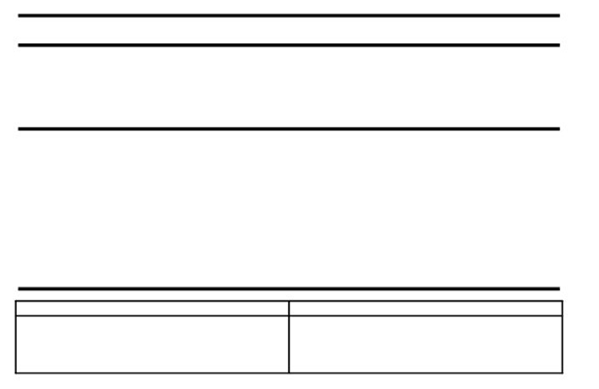
ECE 53: Fundamentals of Electrical Engineering

Laboratory Assignment #3:
Operational Amplifier Circuits and RC Time Constants
General Guidelines:
- Record data and observations carefully for each lab measurement and experiment.
- You must obtain Lab. Assistant’s signature on each page of your lab data before
leaving the lab. Signed pages must be included in the report.
- Make sure you understand the experiment procedure before executing it. You must
obtain enough data to complete the various parts of the procedure.
- Request Lab Assistant’s help to verify your circuit before turning on the power
supplies and generators.
- Please operate the equipment in a reasonable manner. Avoid power supply short
circuits. Report failures to the Lab. Assistant.

Parts: Equipment:
-Resistors as needed Breadboard
-Op-Amp integrated circuits (uA741) Digital Multimeter (DMM)
Signal Generator
Oscilloscope
Objective:
The objective of this session is to implement various operational amplifier (Op-Amp) and understand RC time constants.
Background:
Operational Amplifier
An operational amplifier (op-amp) is a device with two inputs and a single output. The output of the amplifier vo is given by the formula:
.
Where A is the open-loop voltage gain of the amplifier, v+ is the non-inverting input voltage and v- is the inverting input voltage. Both v+ and v- are node voltages with respect to ground. Typically, the open-loop voltage gain A is on the order of 105 - 106. A resistor is placed between the output node and the inverting input to provide feedback and adjust amplification. When an op-amp circuit behaves linearly, the op-amp adjusts its output current such that the voltage difference between the two inputs is nearly zero.
Another important feature of the op-amp is that its input resistance is very large and may be taken as infinite in many applications. The most common type of op-amp is the 741 which has an input resistance of 2 MΩ. This is large enough to be considered infinite in most applications. Because of the high input resistance, only a very small current flows into either input of an op-amp. In practical op-amp circuits, the current flowing into either of the inputs is usually on the

order of μA. In the case of an ideal op-amp, where the single assumption is made that the open-loop voltage gain A goes to infinity,
where ii is defined to be the current entering the non-inverting input and exiting the inverting input. Equations 2 and 3 can be used to analyze most of the properties of op-amp circuits.
Op Amp Symbol
Figure 1 shows an operational amplifier with an open-loop voltage gain A.
Figure 1. Operational Amplifier
The terminals labeled +vcc and -vcc are power supply connections to the op-amp and set limits on the voltage which can be produced at the output node. The op-amp we will be using is the 741 as shown in Figure 2.
Figure 2: 741 Operational Amplifier
To use this IC, you must insert it into your board as shown in Figure 3. When properly positioned, the opamp straddles the gap in the middle of the terminal strip with the 14 pins snuggly fit into individual holes in the terminal strip. Observe the notch at one end of the op-amp chip. This notch is used for orientation and identification of the pins. With the notch positioned as shown, pin 1 is always to the left of the notch.

Op Amp Configuration
As discussed earlier, amplifier circuits that utilize op-amps as linear amplifiers require feedback circuits to control the voltage gain (amplification). The output voltage of the op-amp can never exceed the power supply voltage levels, called "the rails" of the power supply. In this section, we shall examine two types of amplifier configurations for the op-amp (Inverting and Non-inverting) and the voltage gain provided by each.

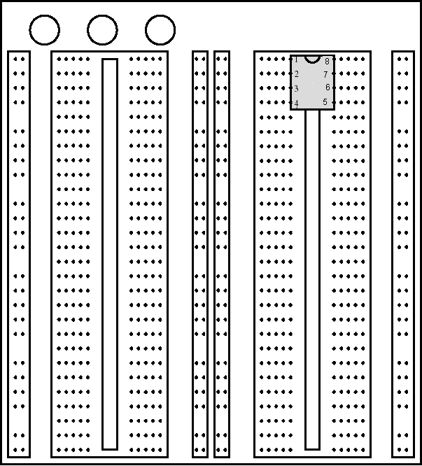
Figure 3: Proto Board with inserted 741.

Inverting Amplifier
Figure 4 shows an op-amp in the inverting configuration along with the power supply connections +vcc and -vcc. Future circuit diagrams will show only the signal portion of the circuit with the understanding that the power supply connections are required for proper operation of the circuit. To analyze this circuit, we will use Kirchhoff's Current Law (KCL) to determine the output node voltage vo and the circuit voltage gain given by the formula,
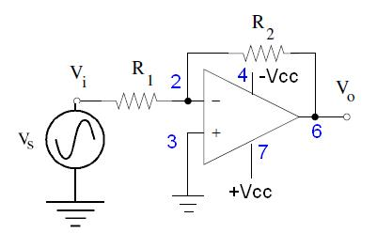
It is important to distinguish between the voltage gain of the circuit and the open-loop voltage gain of the op-amp. The op-amp is only part of the amplifier circuit. The open-loop voltage gain A of the op-amp is the voltage gain from the two op-amp inputs to the op-amp output. While the output node of the whole amplifier circuit may be the output node of the op-amp, the input to the amplifier circuit will not be, in general, a voltage applied across the input terminals of the op-amp.
Figure 4: Inverting operational amplifier circuit

To analyze an op-amp circuit we first look at the op-amp input nodes (2 and 3). Assuming an ideal op-amp, no current flows into either of the op-amp inputs (Equation 3). The current through R3 is zero and therefore v3 = 0. From Equation 2 we know that v2 = v3 = 0.
To find the voltage gain (of the amplifier circuit), we need to divide the output voltage by the input voltage:
Note that the final voltage gain is negative, thus the name inverting amplifier. However, sometimes a negative voltage gain is not desired. In such a case, one could use the output of the inverting amplifier as the input to a second inverting amplifier which would cause the total voltage gain to be positive. However, a simpler method would be to use the non-inverting amplifier configuration.
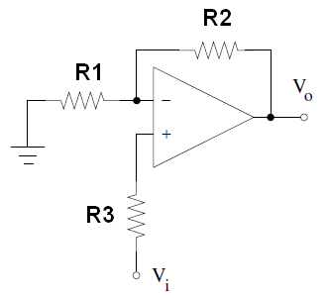
Non-inverting Op Amp
The basic configuration for a non-inverting amplifier is shown in Figure 5.
Figure 5: Non-inverting operational amplifier circuit
Time Constant
All Electrical or Electronic circuits or systems suffer from some form of time-delay between its input and output, when a signal or voltage, either continuous, (d.c.) or alternating (a.c.) is firstly applied to it. This delay is generally known as the time delay or time constant of the circuit and it is the time response of the circuit when a step voltage or signal is applied. The resultant time constant of any circuit or system will mainly depend upon the reactive components either capacitive or inductive connected to it and is a measurement of time with units of, Tau - τ
When an increasing d.c. voltage is applied to a capacitor the capacitor draws a charging current, and when the voltage is reduced, the capacitor discharges. Because capacitors store electrical energy they act like small batteries and are able to store or release the energy as required. This charging (storage) and discharging (release) of a capacitor is never instant but takes a certain amount of time to occur with the time taken for the capacitor to charge or discharge to within a certain percentage of its maximum supply value being known as its Time Constant (τ).

If a resistor is connected in series with the capacitor (RC Circuit), the capacitor will then charge up gradually through the resistor until the voltage across the capacitor reaches that of the supply voltage. The time required for this to occur is equivalent to about 5 time constants or 5T. This time constant T, is measured by τ = R x C, in seconds, where R is the value of the resistor in ohms and C is the value of the capacitor in Farads. Then this 5T can also be thought of as "5 x RC".
RC Charging
The figure below shows a Capacitor, (C) in series with a Resistor, (R) connected across a DC battery supply (Vs) via a mechanical switch. When the switch is closed, the capacitor will gradually charge up through the resistor until the voltage across it reaches the supply voltage of the battery. The manner in which the capacitor charges up is also shown below.
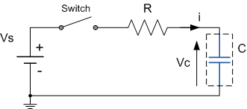
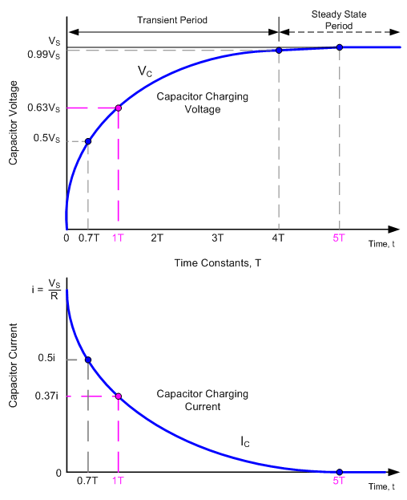
Figure 6. RC Charging Circuit and Charging/Discharging Curves

Let us assume that the Capacitor, C is fully "discharged" and the switch is open. When the switch is closed the time begins at t = 0 and current begins to flow into the capacitor via the resistor. Since the initial voltage across the capacitor is zero, (Vc = 0) the capacitor appears to be a short circuit and the maximum current flows through the circuit restricted by resistor R. This current is called the Charging Current and is found by using the formula: i = Vs/R.
The capacitor now starts to charge up with the actual time taken for the charge on the capacitor to reach 63% of its maximum possible voltage, in our curve 0.63Vs is known as the Time Constant, (T) of the circuit and is given the abbreviation of 1T.
After a period equivalent to 4 time constants, (4T) the capacitor is virtually fully charged and the voltage across the capacitor is now approx 99% of its maximum value, 0.99Vs. The time period taken for the capacitor to reach this 4T point is known as the Transient Period. After a time of 5T the capacitor is now fully charged and the voltage across the capacitor, (VC) is equal to the supply voltage, (Vs). As the capacitor is fully charged no more current flows in the circuit, the time period after this 5T point is known as the Steady State Period.
As the voltage across the capacitor Vc changes with time, and is a different value at each time constant up to 5T, we can calculate this value of capacitor voltage, Vc at any given point, for example.
Laboratory Experiment & Procedure:
Part A – Inverting Amplifier
Circuit Analysis:
- For the inverting circuit, shown in figure 4, calculate the voltage gain through hand analysis. (Assume ideal opamp with negative feedback.)
PSPICE Simulation:
Set up an inverting amplifier circuit as shown with R1 = 5 kΩ and R2 = 20 kΩ. Use the device library in PSPICE for uA741. Set the input signal amplitude as a 1 volt peak-to-peak, 10 kHz sine wave. Use +10 V for +Vcc and -10 V for -Vcc.
- Perform a transient simulation to examined the input and output signal. Plot both Vi and Vo.
- Calculated the simulated gain.
Measurement Procedure:
- Select, measure, and record the values of three resistors, R1 = 5kΩ and R2 = 20kΩ. Obtain a 741 op-amp. Assemble the circuit shown in Figure 4. Be sure to include the power connections +vcc and -vcc from the power supply circuit of Figure 7 to +vcc and -vcc of the 741 chip as shown in Figure 4. In addition, the ground nodes shown in Figure 4 are to be connected to the common node of Figure 7. Note that Figure 4 shows two +vcc connections. There are two 741 opamps in each 741 chip. There is a separate +vcc for each op-amp. Connect a wire between the two +vcc pins. Also note that the pins labeled NC are not connected to anything. Use +10 V for +Vcc and -10 V for -Vcc.
- Using the function generator apply a 1 volt peak-to-peak, 10 kHz sine wave as vS. Note that you need to verify the peak-to-peak voltage using the oscilloscope.
- Using the oscilloscope, display both the op-amp's input and output waveforms. You can do this by using channel 1 at the input and channel 2 for the output. Find the peak-to-peak voltage of the output waveform. Print out the waveforms

- Record the peak-to-peak voltage of vO and find the voltage gain of this op-amp configuration (Equation 4.)
- Increase the peak-to-peak voltage of the function generator until the top of the output sine wave is being cut off. This effect is called clipping, and it occurs when the desired amplification would produce an output voltage greater than the bounds of -vcc and +vcc dictated by the power supply. Measure the voltage of the top half of the sine wave and record this value. Do the same thing with the bottom half of the sine wave. How do these values compare to the values recorded for +vcc and -vcc?
Comparison/Discussion:
- Compare the voltage gain you found in the experiment and PSPICE to the theoretical voltage gain of the inverting opamp. Explain any discrepancies.

Part B – Non-inverting Amplifier
Circuit Analysis:
- For the non-inverting circuit, shown in figure 5, calculate the voltage gain through hand analysis. (Assume ideal opamp with negative feedback.)
PSPICE Simulation:
Set up an inverting amplifier circuit as shown with R1 = 5 kΩ, R2 = 20 kΩ, and R3 = 5 kΩ. Use the device library in PSPICE for uA741. Set the input signal amplitude as a 1 volt peak-to-peak, 10 kHz sine wave. Use +10 V for +Vcc and -10 V for -Vcc.
- Perform a transient simulation to examined the input and output signal. Plot both Vi and Vo.
- Calculated the simulated gain.
Measurement Procedure:
- Select, measure, and record the values of three resistors, R1 = 5 kΩ, R2 = 20 kΩ, and R3 = 5 kΩ . Obtain a 741 op-amp. Assemble the circuit shown in Figure 5.
- Using the function generator apply a 1 volt peak-to-peak, 10 kHz sine wave as vS. Note that you need to verify the peak-to-peak voltage using the oscilloscope.
- Using the oscilloscope, display the op-amp's output waveform. Record the peak-to-peak voltage of the output waveform. Print out the waveforms.
- Find the voltage gain of this op-amp configuration
- Increase the peak-to-peak voltage of the function generator until you achieve clipping. Measure the voltage of the top half of the sine wave and record this value. Do the same thing with the bottom half of the sine wave. How do these values compare to the values recorded for +vcc and -vcc?
Comparison/Discussion:
- Compare the voltage gain you found in the experiment and PSPICE to the theoretical voltage gain of the non-inverting opamp. Explain any discrepancies.

Part C – Inverting Amplifier with RC time constant
Figure 7: Inverting Amplifier with RC time constant
Circuit Analysis
- For circuit shown in figure 7, calculated step response at the output V_{O}(t).
- Calculated the time constant of the circuit.
- Calculate the DC voltage gain through hand analysis. (Assume ideal opamp with negative feedback. Hint: At DC, the capacitor looks like an open circuit.)
PSPICE Simulation:
Set up an inverting amplifier circuit as shown with R1 = 5 kΩ, R2 = 10 kΩ, and C2 = 1 nF. Use the device library in PSPICE for uA741. Set the input signal amplitude as a 1 volt peak-to-peak, 10 kHz square wave. (You can use the VPULSE function) Use +10 V for +Vcc and -10 V for -Vcc.
- Simulated the step response of the circuit in figure 7. Plot both Vi and Vo. (You only need more period of the wave). Calculated the simulated gain.
- From the simulated step response, find the time constant.
Measurement Procedure:
- Select, measure, and record the values, R1 = 5 kΩ, R2 = 10 kΩ, and C2 = 1 nF. Obtain a 741 op-amp. Assemble the circuit shown in Figure 7. Use +10 V for +Vcc and -10 V for -Vcc.
- Using the function generator apply a 1 volt peak-to-peak, 10 kHz square wave as vS. Note that you need to verify the peak-to-peak voltage using the oscilloscope.
- Using the oscilloscope, display the op-amp's output waveform. Record the peak-to-peak voltage of the output waveform. Print out the waveforms. Find the voltage gain of this op-amp configuration
- Estimate the time constant of the circuit.
Comparison/Discussion:
- Compare the voltage gain and time constant you found in the experiment and PSPICE to the theoretical values. Explain any discrepancies

