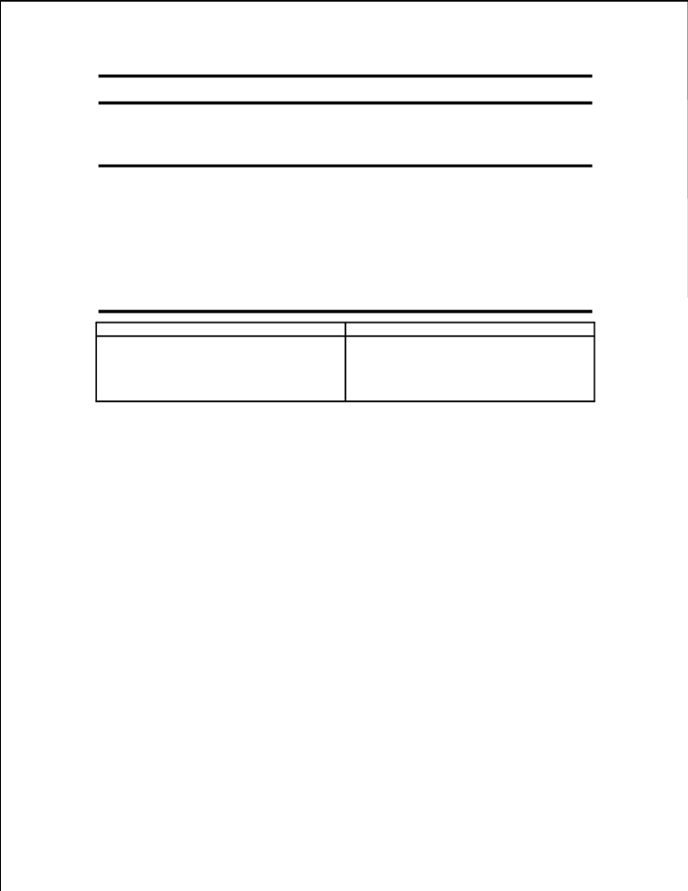

ECE 53: Fundamentals of Electrical Engineering
Laboratory Assignment #1:
Instrument Operation, Basic Resistor Measurements and Kirchhoff’s Laws

General Guidelines:
- Record data and observations carefully for each lab measurement and experiment.
- You must obtain Lab. Assistant’s signature on each page of your lab data before
leaving the lab. Signed pages must be included in the report.
- Make sure you understand the experiment procedure before executing it. You must
obtain enough data to complete the various parts of the procedure.
- Request Lab Assistant’s help to verify your circuit before turning on the power
supplies and generators.
- Please operate the equipment in a reasonable manner. Avoid power supply short
circuits. Report failures to the Lab. Assistant.

Parts: Equipment:
- Resistors as needed Breadboard
Digital Multimeter (DMM) Frequency Counter
Signal Generator
Oscilloscope
Objective:
The objective of this session is to learn to properly use the instruments at the lab and to verify the application of Kirchhoff’s laws to simple circuits through laboratory measurements.
Instrument Description:
DC Power Supply
The DC power supply is used to generate either a constant voltage (CV) or a constant current (CC). That is, it may be used as either a DC voltage source or a DC current source. You will be using it primarily as a voltage source. Recall that DC is an acronym for direct current. DC means constant with respect to time. The voltage produced by a power supply is controlled by a knob labeled voltage. If the power supply allows for current adjustment, current is limited by adjusting the knob labeled current. As long as the circuit does not attempt to draw more current than the value set by the current knob, the voltage will remain constant. Current limiting allows the power supply to be set such that the power supply does not generate more current than desired. This can be useful to prevent damage to equipment and parts which may be unable to handle excessive currents.
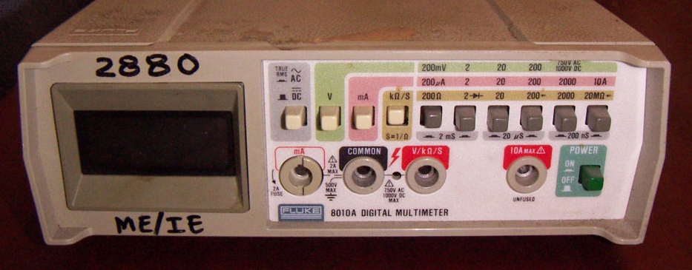
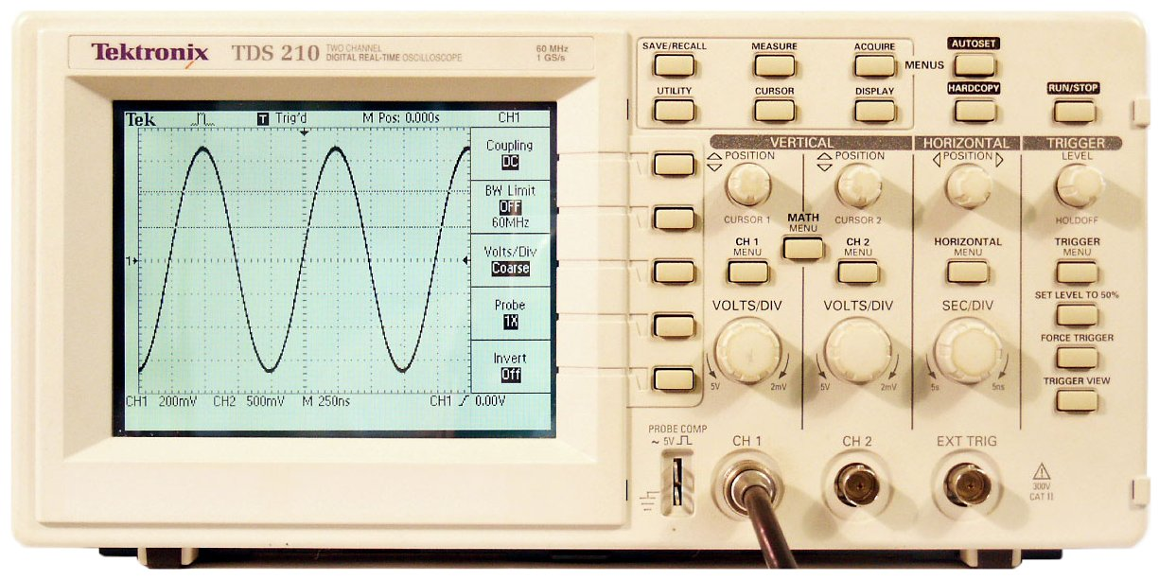
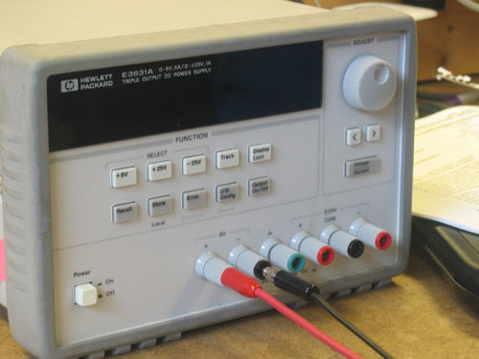
DC power supply Digital Multimeter Oscilloscope

Function Generator
The function generator is used to provide voltages that vary with time. It has four primary waveforms: sine, square, triangular and ramp. There are various parameters that can be varied for each waveform; three of them are of particular interest:
1. Peak-to-peak voltage (0-10 V)
2. Frequency (0-15MHz)
3. DC offset

To set any of these features, use the knob labeled with the feature you wish to modify.
Digital Multimeter
The digital multimeter measures voltage, current and resistance. There are separate settings for measuring AC and DC values. If you examine the front panel, you will find primary functions are selected using a multi-position knob. Functions are accessed by selecting the desired measurement. For example, to measure DC voltage, you select the DC V option. To measure DC current, use option DC A (or DC mA). The multimeter also has the capability of measuring other quantities such as resistance. There are three aligned holes (banana jacks) in the multimeter. To measure voltage, place the positive terminal in the hole marked with a +V, with the negative terminal in the GND (or -V) hole. The positive hole is red, and the negative is black. To measure current, place the terminal (the terminal at which current enters the multimeter) in the hole labeled A (or mA) and the other terminal in the GND hole. If the multimeter is not auto ranging, you need to select the proper range using the knob until you identify the required range (for example: 200mV, 2V, 20V, 200V for a voltage measurement).When the value you are measuring is stable on the display, read the value.
Oscilloscope
An oscilloscope is used to view a voltage waveform on a screen. An electron beam is generated in the cathode ray tube, directed at the back of the screen, and swept in time along the X-Axis. A voltage applied to the scope probes is amplified and applied to a pair of horizontal metal plates through which the electron beam passes. This voltage deflects the beam in the vertical direction (Y-Axis). The sweep in the electron beam combined with vertical deflection results in the appearance of a waveform on the screen of the scope. The scope has two probes: one for Channel 1 and one for Channel 2. The probes are very expensive (approx. $200 each), so please be careful with them. Each channel has a vertical placement knob used to move the waveform for that channel up and down. Each channel also has a knob used to select the vertical scale of the waveform in terms of volts per division. Divisions are the visible grid lines on the oscilloscope screen. The knob used to set the horizontal scale (in time per division) controls both channels. Some measurements made in this lab can be performed automatically using the Auto-scale feature. When you want to capture a waveform on the screen, the first thing to think of is Auto-scale. This takes the waveform at the input and displays it so that the entire peak-to-peak voltage is displayed as well as several periods. However, you must be careful with this feature and make sure the instrument has captured the right waveform you are trying to visualize. To measure voltage, push the button marked voltage which is located to the right of the screen near the top of the front panel. This will bring up a menu at the bottom of the screen, listing available voltage measurements. The first choice is to select either channel 1 or 2 for measurement. After that, you may select: Peak to Peak voltage (Vp-p), average voltage (Vave), or rms voltage (Vrms). By pressing the corresponding softkeys, you will automatically get the selected measurement. For more choices, press the softkey labeled Next Menu. The next menu will allow you to select other voltage measurements. Time measurements can be obtained by pressing the Time button (located next to the voltage button). This will give you the following menu options: Frequency, Period, Duty Cycle, +Width, -Width, Rise Time, Fall Time, Delay and Phase Difference. This last command, Phase Difference, is useful for computing the difference in phase between waveforms on channels 1 and 2.

Breadboards/Prototyping boards (Proto-boards)
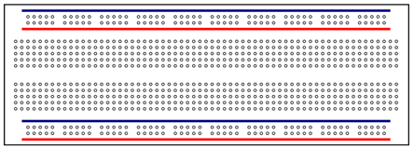
Solderless breadboards are the most typical option to prototype electronic circuits. A prototype is
an initial real implementation of a circuit. It is used to evaluate a design and test actual performance under certain test conditions. Breadboards usually consist of a rectangular plastic enclosure. On the surface of a breadboard, there are many holes for plugging in components (refer to Fig.1).
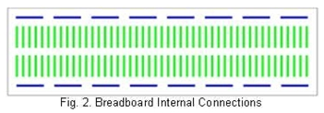
The breadboard consists of metal strips running underneath the enclosure as shown in Fig. 2. These strips are used as interconnection points (nodes) to build circuits. They can be accessed through the appropriate holes.

The horizontal strips shown in Fig.2 are often used for power supply voltages (i.e. V+, GND) and the vertical strips are for the components.
Laboratory Experiment & Procedure:
Part A – Measuring Voltage and Current:
Discuss with your team how you would go about measuring voltage across and current through a
resistor using the multimeter.
Question: How would you place the leads? (ANSWER THIS IN YOUR REPORT)
The following hints may be helpful:
1. As a voltmeter, the multimeter must (ideally) have infinite resistance.
2. As an ammeter, the multimeter must (ideally) have zero resistance.
If not sure about the measurements connection, ask the Teaching Assistant (TA).

Part B - Resistance Measurement:
Most resistors have four colored bands. The first three bands indicate the nominal value of the resistor and the fourth band indicates the tolerance in value. The first two bands form the mantissa and the third the exponent of 10.
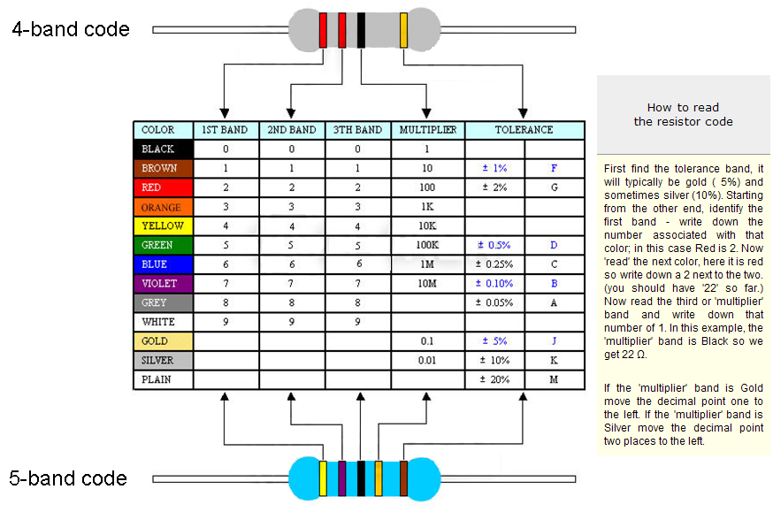
The tolerance band is typically either gold or silver. A gold tolerance band indicates that the measured value will be within 5% of the nominal value. A silver band indicates 10% tolerance. For example a resistor with color code brown-black-red-silver indicates a nominal value of 1 kΩ. The first two bands (brown-black) produce the mantissa (10) and the third band (red) is the exponent of ten (102 = 100). So the value is 10 x 100 = 1K. Since the tolerance band is silver, we can expect the measured value of the resistor to be between 900Ω and 1100Ω.
Select 5 different resistors (write down their color coded values ).
Circuit Analysis:
- Compute the nominal value as indicated by the resistor color code.
Measurement Procedure:
- Set the multimeter to measure resistance. To do this, select the ohmmeter function.
- Determine the actual values of the resistor. The words ``actual" and ``measured" may be used interchangeably.
Comparison:
- Tabulate the nominal value and the measured value of the five resistors.
- Compute and tabulate the percent difference between the actual (measured) value of the resistors and their nominal value as indicated by its color code.

Part C - Measuring the Resistance of Your Body:
Measurement Procedure:
- Holding one probe between the thumb and forefinger of each hand, measure the resistance of your body between your hands. Squeeze the probes tightly so that good contact is established. Record the value of your body's resistance.
- Calculation: Considering that a current of 100-200 mA through your heart will almost certainly kill you, how much voltage across your hands would be lethal?
Part D - Experiment: DC measurement and Ohm's Law
Circuit Analysis:
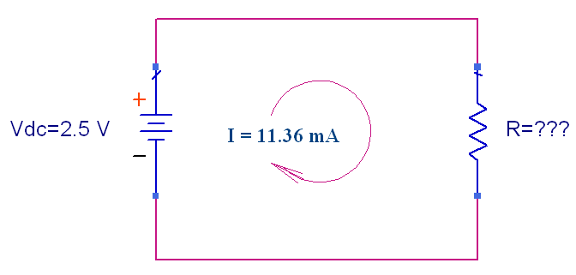
- Calculate the resistance R for the circuit given below using Ohm’s Law (V = IR).
Measurement Procedure:
- Set the DC power supply to provide 5 V as shown in the digital display on the power
supply front panel.
- Set the multimeter to measure DC voltage, making sure the leads are set for voltage, not
current measurement.
- Measure the voltage using the multimeter.
- Disconnect the multimeter from the power supply and connect the oscilloscope leads to
the power supply.
- Adjust the volts/division knob on the oscilloscope until the voltage appears on the screen.
(This should occur around 1 volt/division.)
- Measure the voltage by using the automatic measuring features of the oscilloscope.
- Using the same screen, measure the voltage by hand, i.e. count the divisions and multiply by the number of volts per division. (This number can be found in the upper left corner of the screen.)
- Set the DC power supply to 0 V.
- If the power supply allows current limiting, set the current to 50 mA.
- Connect a 220Ω resistor to the power supply.

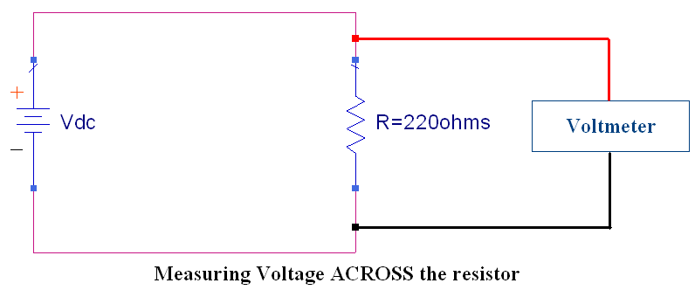
- Connect the multimeter across the resistor and set it to measure DC voltage.
- Measure the current through the resistor using the multimeter.
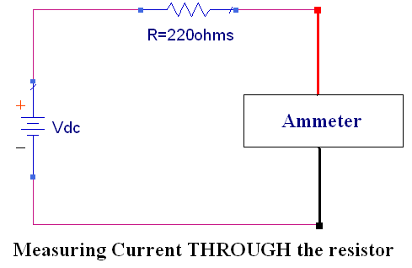
- Increase the voltage (slowly) across the resistor to 1V. Measure and record the voltage across and current through the resistor.
- Repeat voltage and current measurements 10 times for voltages between 1V and 5V (you can perform them in increments of 0.5V) Record your measurements.
- Using Ohm’s law, determine the resistance value for each measurement.
- Find the average resistance from the 10 measurements above.
Comparison:
- Does the average resistance correspond to the nominal value? Calculate the percent difference between the nominal value and the average resistance.

WARNING: Be careful with the DC power supply leads. Avoid letting them touch at all times. When they touch, a short circuit is formed. Consider what would happen if you shorted the wall socket, or a car battery! Short circuits can be dangerous, and care should be taken to avoid them.

Part E - Voltmeter
An ideal voltmeter has infinite resistance: It is an open circuit. Although it is impossible to make a physical voltmeter with infinite resistance, a properly designed voltmeter exhibits a very large internal input resistance. In some experiments, it is important to take into account the finite, non-ideal, internal resistance. To determine the internal resistance of the voltmeter, set up the circuit shown below. The voltmeter reads the voltage across itself, which includes its internal resistance. Since the circuit has only a single branch, the current flowing through the resistor also flows through the voltmeter. From Ohm's Law, if we know the current (I) and the voltage (V_{M}) we can compute R_{M}.
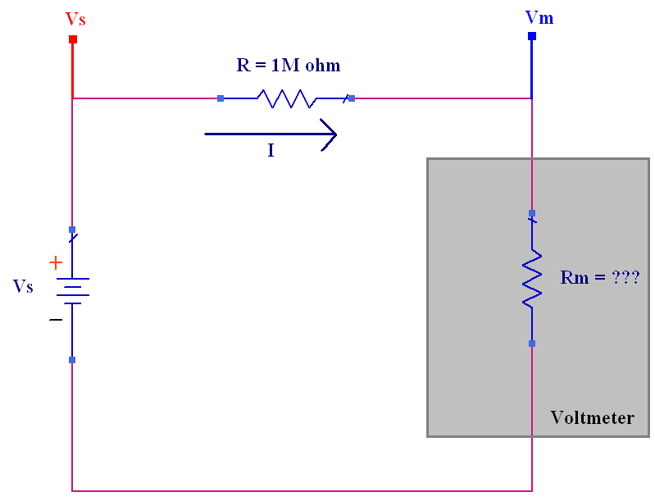
Figure 7: Circuit for measuring voltmeter resistance.
Measurement Procedure:
- Select a 1 MΩ resistor.
- Measure its value (R) using the multimeter.
- Set the power supply to provide 10 V. Measure this voltage (V_{S}) with the voltmeter and record. (Remember, always measure the voltage provided by the power supply with either the voltmeter or the scope. Do not rely on the digital display on the front panel of the power supply.)
- Assemble the circuit in Figure 7.
- Record the voltage measured by the voltmeter (V_{M})
Calculation:
- Compute the internal resistance (R_{M}) of the voltmeter using the appropriate equation.
Question/Discussion:
- What does this tell us about the limitation of the voltmeter? Under what situation, do we expect the voltage read by this voltmeter to be inaccurate?

Part F - Ammeter
An ideal ammeter has zero resistance so that the circuit in which it has been placed is not disturbed. An ideal ammeter is a short circuit. However, as with the voltmeter, no ammeter can ever be ideal, and therefore all ammeters have some (hopefully) small internal resistance. To determine the resistance of the ammeter, you can use the circuit below. According to Ohm's Law, the current in this circuit will be I = V/R where R = R + RM. By using the known quantities I, Vs and R, we can solve for the unknown quantity RM.
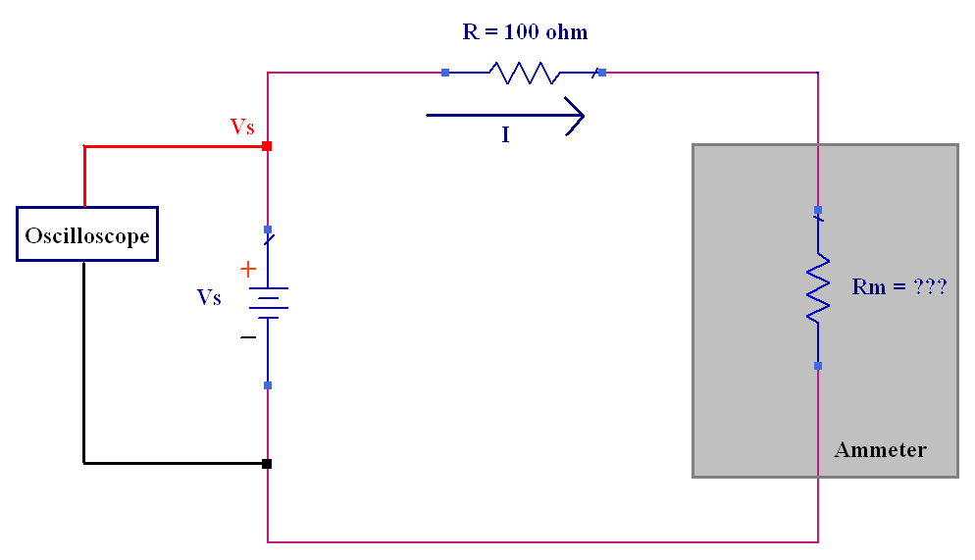
Figure 8: Circuit for measuring ammeter resistance.
In the procedure that follows it is extremely important that you take precise and accurate
measurements. Record each measurement as precisely as the instrument will allow.
Measurement Procedure:
- Select a 100 Ω resistor. Measure and record its actual value (R).
- Design a circuit to measure the internal resistance of the ammeter (i.e. assemble the circuit of Figure 1). Set the multimeter to the ammeter mode for dc current measurement.
- Use the oscilloscope to measure the voltage (V_{S}) across the DC power supply.
- Measure the value of the current (I) using the ammeter.
Calculation:
- Determine the value of RM from the appropriate equation.
Question/Discussion:
- What does this tell us about the limitation of the ammeter? Under what situation, do we expect the current read by this ammeter to be inaccurate?

Part G - Measurement of Time Varying Sources
In this section, we will be using the function generator to provide a time-varying voltage to be measured using the oscilloscope.
Important: The function generator has an internal resistance of 50Ω. The voltage displayed on its front panel is the voltage that would appear at its terminals if it were connected to a 50Ω load. Under open circuit conditions, the voltage across the terminals of the function generator is twice as large as the value indicated on its front panel. This is an important concept and often misunderstood.
If you are located at a lab station that has no printer, complete items 15-17 after one of the lab stations containing a printer becomes vacant.
Measurement Procedure:
- Set the function generator to produce a 10 kHz square wave with 4 Vp-p and 50% duty cycle.
- Connect the oscilloscope channel 1 probe to the leads on the function generator.
- Locate the VERTICAL section on the front panel of the oscilloscope. It is the section which includes the connections of the scope probes to the scope.
- Press the softkey labeled 1. A menu will appear on the bottom of the scope screen. The items that appear on this menu are: channel activation, coupling, bandwidth limiter, inversion, vernier, and probe calibration. Examine the setting for probe. It should be on 10. If it is not, set the probe value to 10. This tells the scope that the probe reduces the signal strength by a factor of 10. All of the scope probes in this lab are ``10x" probes. It is a good idea to get in the habit of checking the probe setting at the beginning of each lab.
- Press Auto-Scale on the oscilloscope to view the signal produced by the function generator.
- Using the automatic features of the oscilloscope, determine the peak-to-peak voltage. Observe that the measured peak-to-peak voltage is approximately twice the peak-to-peak voltage shown on the front panel of the function generator.
- Using the automatic features of the oscilloscope, determine the frequency, and the period of the square wave voltage.
- Measure the peak-to-peak voltage by hand, i.e. count the vertical divisions from the minimum to the maximum and multiply by the number of volts per division. The “volts per division” setting is shown in the upper left corner of the scope screen.
- Using the same screen, measure the period of the square wave by hand, i.e. count the number of horizontal divisions in one period of the sine wave. The time per division setting is shown at the top-right-center of the scope screen.
- Connect the function generator across a 50Ω resistor. Leave the settings on the function
generator unchanged
- Connect the oscilloscope channel 1 probe across the resistor (and function generator).
- Press Auto-Scale on the oscilloscope to view the signal produced by the function generator.

- Using the automatic features of the oscilloscope, determine the peak-to-peak voltage. Observe that the measured peak-to-peak voltage is approximately the same as the peak-to-peak voltage shown on the front panel of the function generator.
Hence, the voltage at the terminals of the function generator is load dependent. Whenever you use the function generator to provide a voltage waveform and desire specific amplitude, you must use either the multimeter or the scope to set the desired voltage because the value shown on the front panel of the function generator is valid only for a 50 Ω load.
- PRESS RUN/STOP to stop the waveform!!!
- Press the Print/Utility softkey on the scope. It is located to the right of Autoscale. Then press the RS-232 Menu softkey. Make sure the resolution is set to low. Press the previous menu softkey. Press the print screen softkey
Calculation:
- Using the formula frequency = 1/period , determine the frequency of the square wave using the period measured in #9.
Comparison/Question:
- Compare the values for the peak-to-peak voltage and frequency that were 1) specified by the function generator, 2) measured by the oscilloscope and 3) measured by hand. You can do this by finding the percent difference. Explain any large discrepancies.
- Do the measurements made by hand differ from those made by the oscilloscope? Which do you think are more accurate? Justify your answer.
Part H - Voltage Divider and Kirchhoff’s Voltage Law (KVL)
In many occasions we need to bias the circuit components with a voltage that is different than the power supply voltage. Other times we need to feed back a signal proportional to the output signal of one part of the circuit to another part. The voltage divider circuit below is the simplest circuit that does these functions and is used extensively in electronic circuits.
Objective: The objective of this session is to verify the application of Kirchhoff’s Voltage Law to the voltage divider through circuit analysis, simulations, and laboratory measurements.
Circuit Analysis:
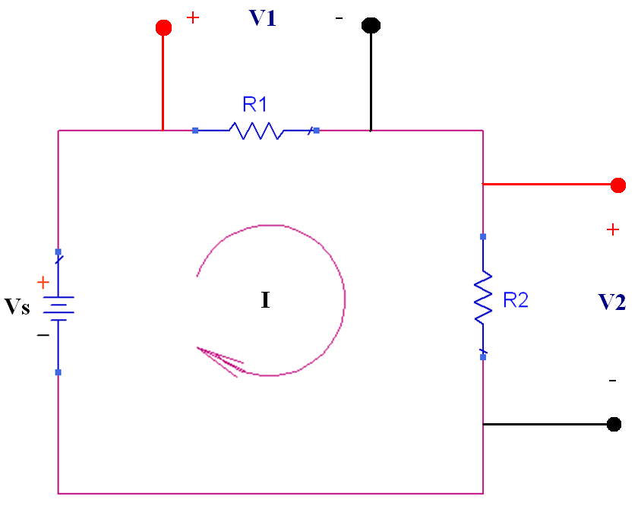
- For the voltage divider above, find the voltages V1 and V2 as a function of the resistances (R1 & R2) and the supply voltage (Vs).

Design 3 voltage divider circuits using a 6-volt source and repeat steps #2 - #7 for each of the three circuits:
  - Two different resistors less than 100 kΩ (R1 ≠ R2).
  - Two equal resistors less than 100 kΩ (R1 = R2).
  - Two 10 MΩ resistors (R1 = R2 = 10 MΩ).

For each of the 3 voltage divider circuits:
- Verify Kirchhoff's Voltage Law (KVL) by showing that V1 + V2 = Vs.
- Calculated the theoretical voltages V1 and V2 using the equations you derived in #1.
  - Sanity Check: Take the summation of V1 and V2 calculated from #1 to verify Vs.
PSPICE Simulation:
- Use PSPICE to simulate the 3 voltage divider circuits using the nominal resistance value for R1 and R2. Use “Bias Point” analysis to find the value of V1 and V2.
- Verify KVL by taking the summation of V1 and V2 and compare it to Vs.
- In the case of the two 10 MΩ resistors, in the simulation, include the voltmeter internal resistance found in Part E.
Measurement Procedure:
- Obtain resistors for R1 and R2 your designed values from the parts bin.
- Measure the resistor values using the multimeter as an ohmmeter.
- Build the voltage divider circuit using the resistors on a lab breadboard.
- Set the power supply to 6V. Use the voltmeter to ensure the proper setting.
- Using the voltmeter, measure the voltage across each resistor (V1 & V2). Record these values, as always.
Comparison/Question:
- Create a table presenting theoretical, simulated, and measured voltages (V1, V2, & Vs) along with percent difference. Explain any large discrepancies.
- Consider whether your theoretical values for the voltages across each resistor should include the effect of the voltmeter internal resistance. Comment on the accuracy of measurements made considering the internal resistance of the voltmeter.
- In the case where two 10 MΩ resistors were used, is KVL satisfied?. If not, why? Do you need to include the effect of the voltmeter internal resistance?

Part I – Current Divider and Kirchhoff’s Current Law (KCL)

Objective: The objective of this session is to verify the application of Kirchhoff’s Current Law to the current divider through circuit analysis, simulations, and laboratory measurements.

Circuit Analysis:
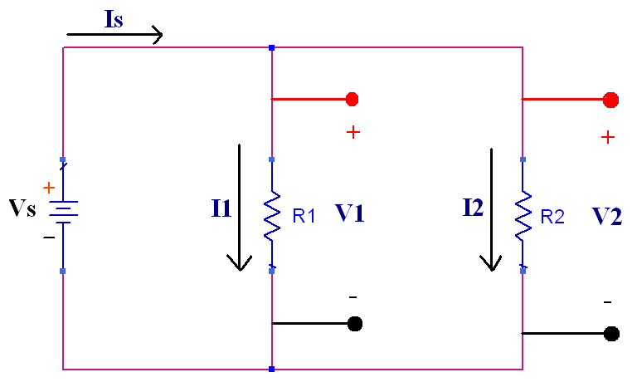
- For the current divider above, find the currents I1 and I2 as a function of the resistances (R1 & R2) and the supply current (Is).

Design 3 current divider circuits using a 6-volt source and repeat steps #2 - #9 for each of the three circuits:
  - Two different resistors less than 100 kΩ (R1 ≠ R2).
  - Two equal resistors less than 100 kΩ (R1 = R2).
  - Two 10 Ω resistors (R1 = R2 = 10 Ω).

For each of the 3 current divider circuits:
- Verify Kirchhoff's Current Law (KCL) by showing that I1 + I2 = Is.
- Calculated the theoretical currents I1 and I2 using the equations you derived in #1.
  - Sanity Check: Take the summation of I1 and I2 calculated from #1 to verify Is.
PSPICE Simulation:
- Use PSPICE to simulate the 3 current divider circuits using the nominal resistance value for R1 and R2. Use “Bias Point” analysis to find the current value of I1 and I2.
- Verify KCL by taking the summation of I1 and I2 and compare it to Is.
- In the case of the two 10 Ω resistors, in the simulation, include the ammeter internal resistance found in Part F.
Measurement Procedure:
- Obtain resistors for R1 and R2 your designed values from the parts bin.
- Measure the resistor values using the multimeter as an ohmmeter.
- Build the current divider circuit using the resistors on a lab breadboard.
- Set the power supply to 6V. Use the voltmeter to ensure the proper setting.
- Using the voltmeter, measure the voltage across each resistor (V1 & V2). Record these values, as always.

- Configure the multimeter to measure current. Remember that this requires two things:
  - Remove the terminal of the red probe from the voltage/resistance measuring receptacle and insert it in the current measuring receptacle on the front panel of the multimeter.
  - Then press the DC current button, also on the front panel of the multimeter.
- Measure the current through the 6V source (Is). Remember that you have to break the circuit and insert the ammeter in series with the 6V source to allow the current to flow through the ammeter.
- Measure the current through each resistor (I1 & I2).

IMPORTANT NOTE for current divider circuit - part c: Before you perform the measurements for this current divider using 10 Ω resistors, place a 10kΩ resistor in series with the current divider in order to avoid exceeding the resistors power rating. Make sure you record the voltages across the series 10kΩ resistor and the voltage of the current divider. Verify Kirchhoff’s Voltage Law (KVL).
Comparison/Question:
- Create a table presenting theoretical, simulated, and measured currents (I1, I2, & Is) along with percent difference. Explain any large discrepancies.
- Consider whether your theoretical values for the current through each resistor should include the effect of the ammeter internal resistance. Comment on the accuracy of measurements made considering the internal resistance of the ammeter.
- In the case where two 10 Ω resistors were used, is KCL satisfied? If not, why? Do you need to include the effect of the ammeter internal resistance?

